Locking and unlocking records
Maciej Szymczak
Version 2026.04.07
Functional description 1
Technical description 2
How was it implemented? 2

Salesforce created a standard solution for locking and unlocking records by flow. See https://help.salesforce.com/s/articleView?id=sf.flow_ref_elements_actions_lockrecord.htm&type=5 for more.

I recommend still using this enhancement because:
- This enhancement provides function: ApprovalIsLocked, not available in standard
- Standard Lock raises an error is record is already locked (this enhancement is not throwing an error)

Functional description
This customization provides apex classes that can be executed by flow so that you can build the Quick Action available in Lightning that locks or unlocks the record.
Why do we need it?
In Salesforce Classic there is a button . The button unlocks the Opportunity.
This functionality is not available in Lightning, there is open idea on this here: https://success.salesforce.com/ideaView?id=0873A0000003XR6QAM.

Notes:
- Mark the checkbox Enable record locking and unlocking in Apex as true and save in Setup > Create > Workflows and Approvals > Process Automation Settings

- Optionally: Select this checkbox
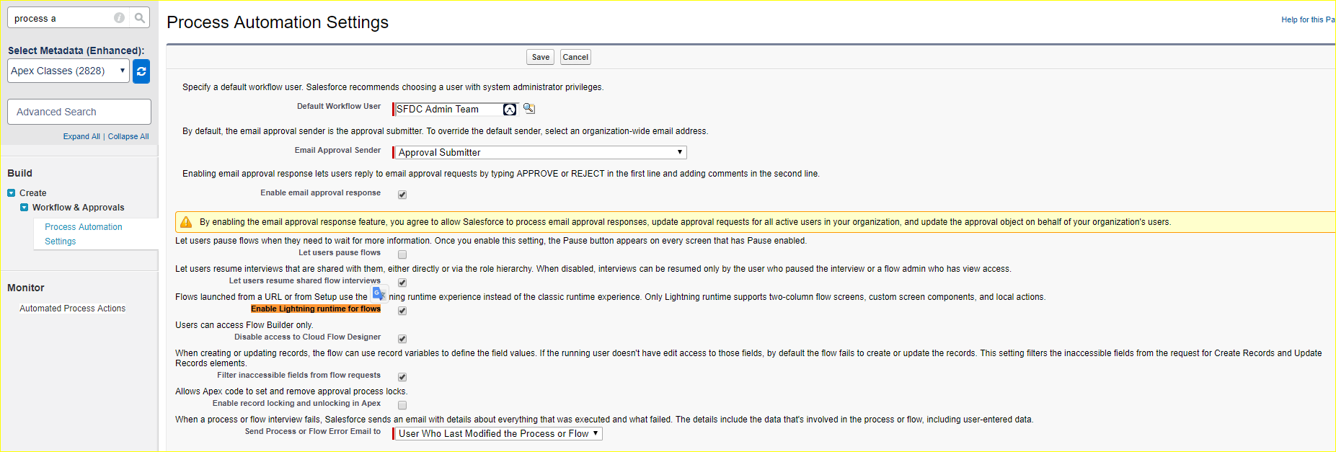
It causes flows are rendered in Lighting style.
- Build the Weblink or Quick action
- In hybrid environment (classic and lightning)
Create and add the Weblink to page layouts

- In Lighting environment
Created and the Quick Action to page layouts

Technical description

Add apex action to your flow and select ApprovalIsLocked, ApprovalLock or ApprovalUnlock.

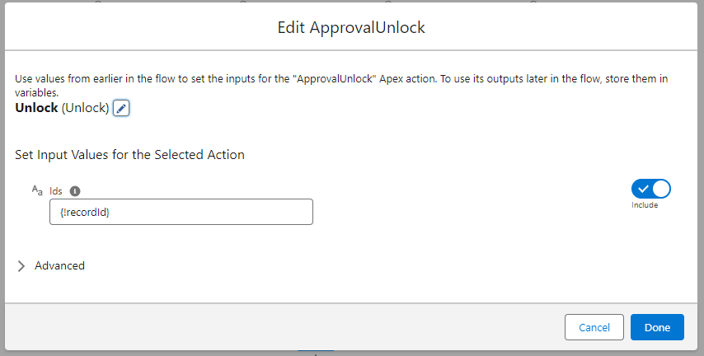

How was it implemented?
Apex classes were created. Classes expose methods available in flows.
public class ApprovalIsLocked {

/*
* This apex class is used by flows
* @author Maciej Szymczak
* @version 2019.08.16
*/

@InvocableMethod
public static List<Boolean> Run(List<String> Ids) {
List<Boolean> result = new List<Boolean>();
for (String p : Ids) {
result.add( Approval.isLocked (p));
}
return result;
}
}

